Homepage

<https://tf-react-bieber.vercel.app/homepage3>

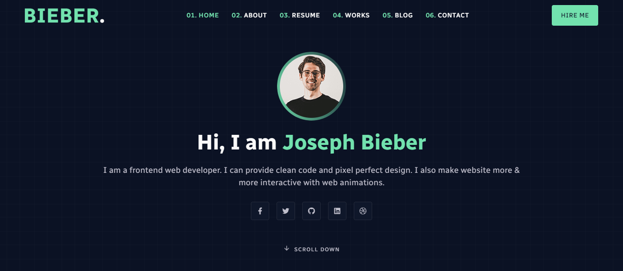

Top Left Logo

<https://reactjsexample.com/software-developer-master-portfolio-template-with-react/>

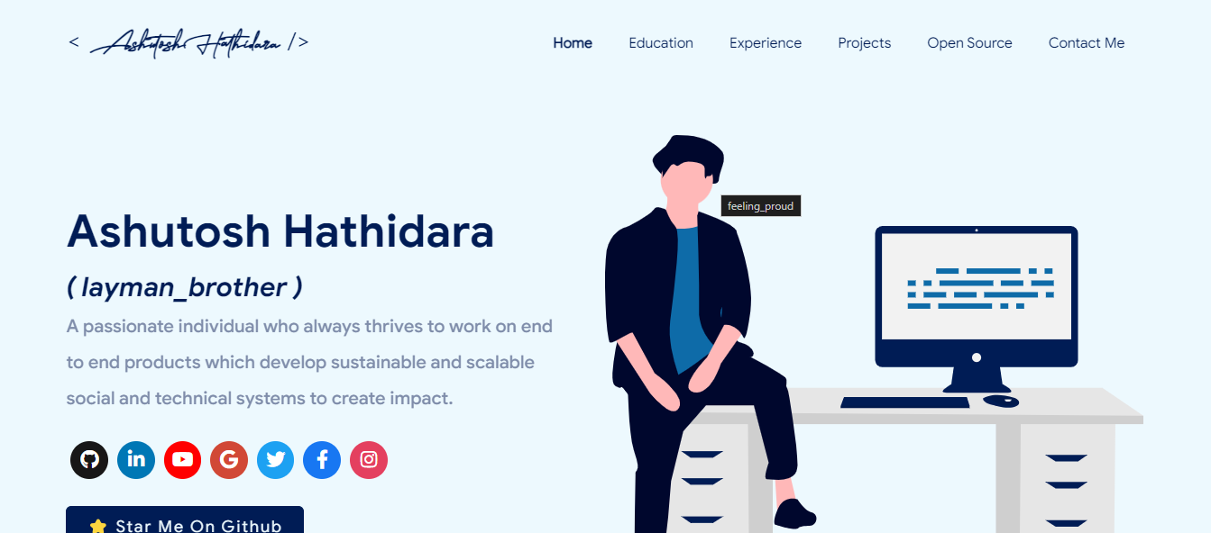

Contact Button

<https://preview.themeforest.net/item/jackcreative-react-nextjs-portfolio-template/full_screen_preview/47727028>

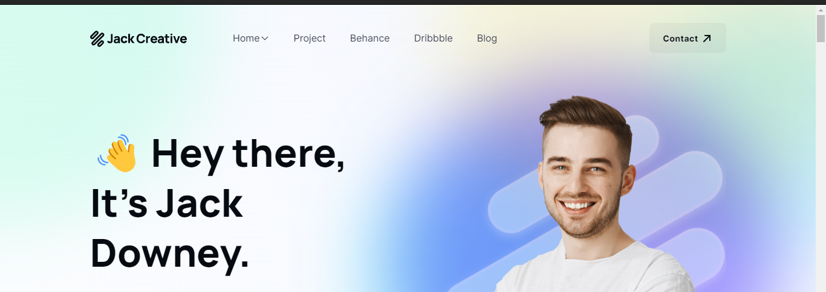

Footer

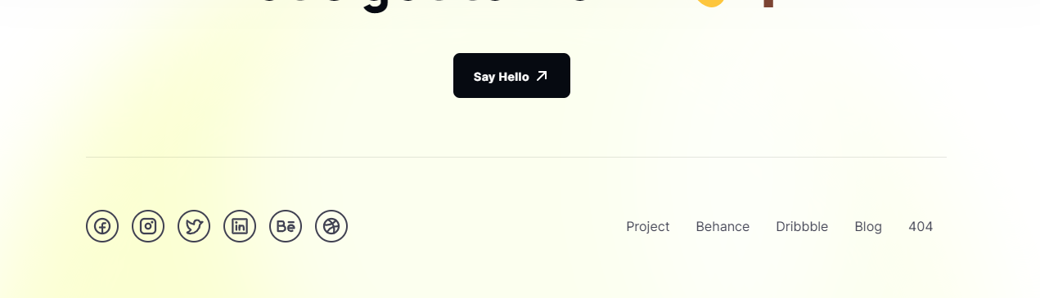

Content Loading Inspiration

<https://www.seekvisualartist.com/>

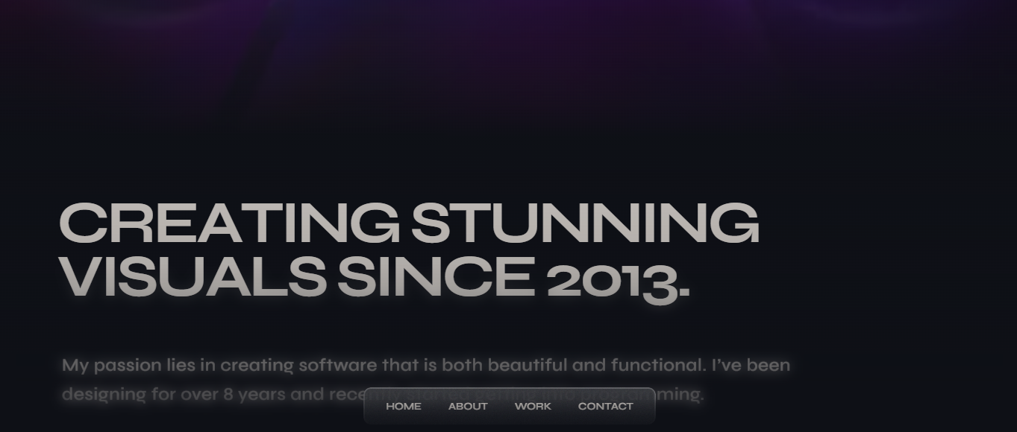

Another loading inspiration

<https://www.shubhporwal.me/>

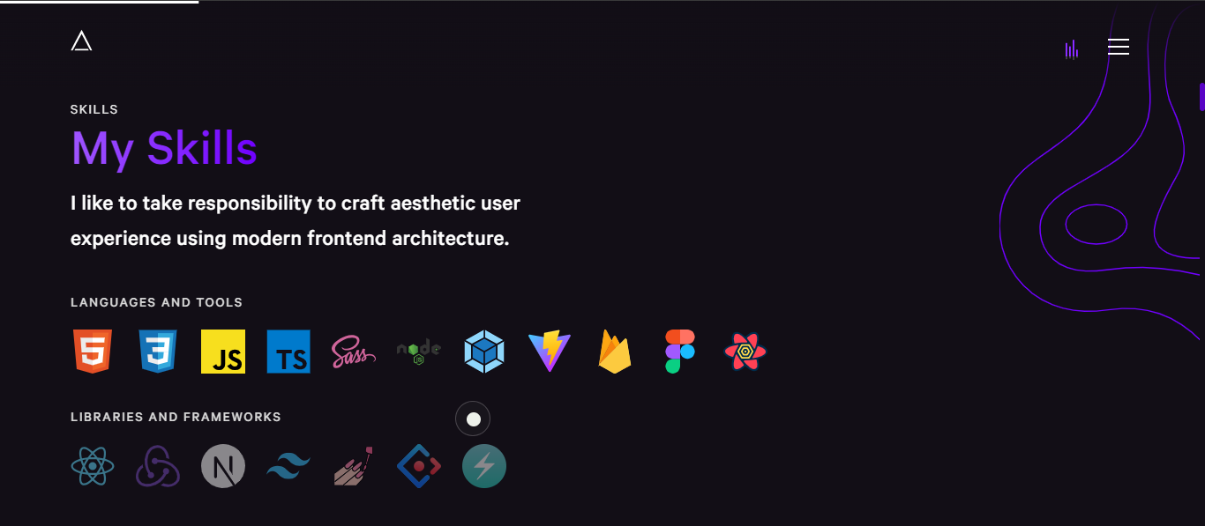

Navbar

https://reactfolio.tharindu.dev/

Email Gif

https://siddhesh-s-patil-portfolio.netlify.app/

About Inspiration—1

<https://prasadchavan.me/about>

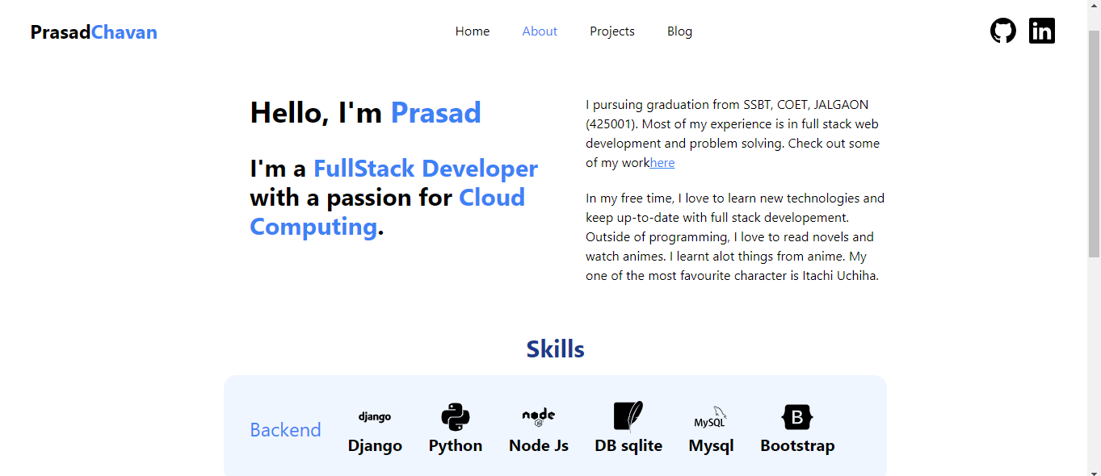

Good Templates Page with source code

<https://reactjsexample.com/tag/portfolio-page/>

About Skills section

<https://ashutoshhathidara.com/#/home>

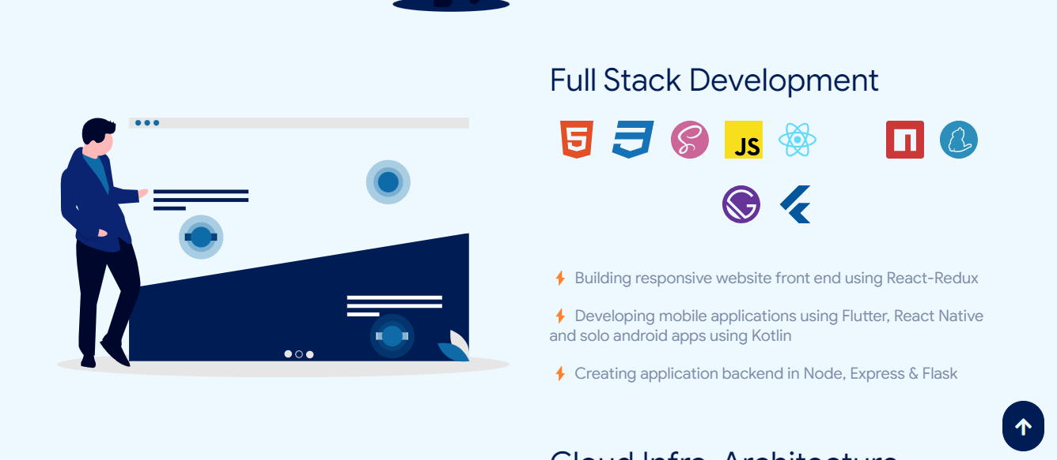

Front Page Loading Text Animation

<https://dunks1980.com/>

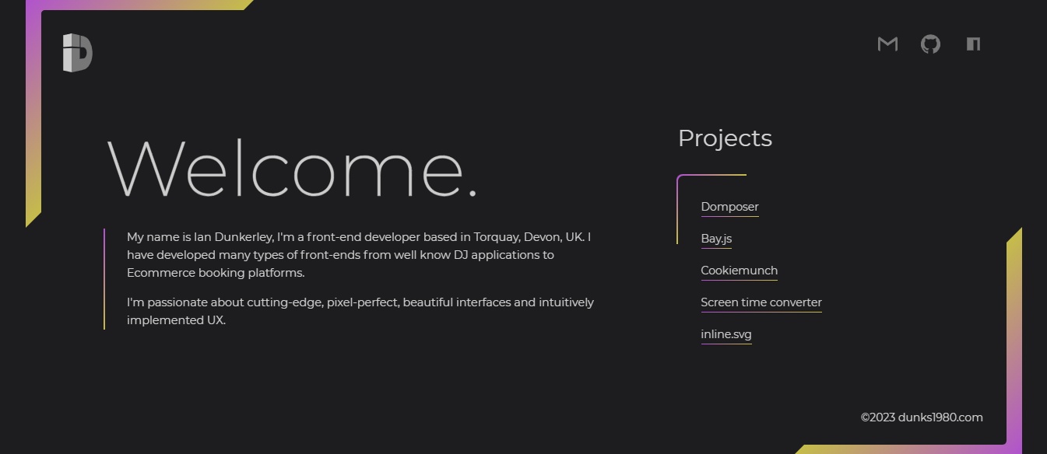

Text Hover effect

<https://www.dejan.works/work/>

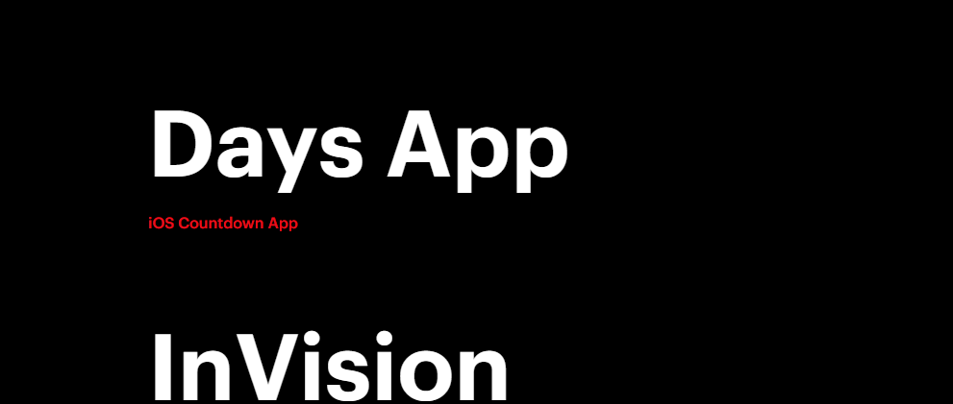

About Section Priority-1

<https://mattfarley.ca/>

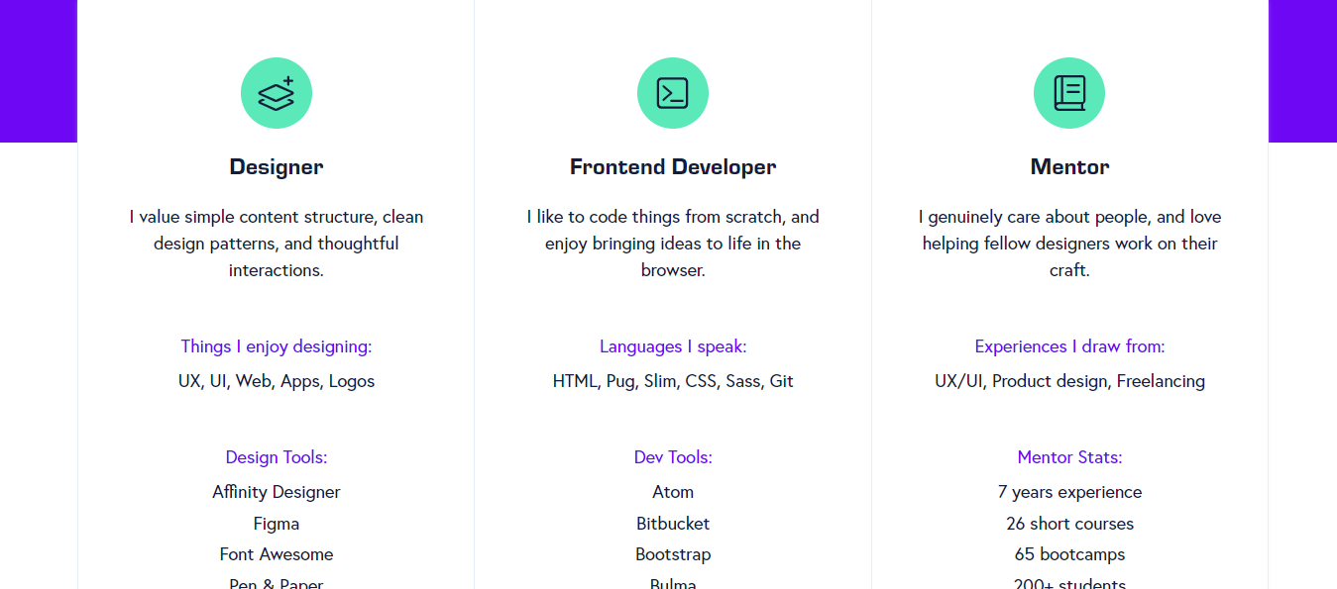

Cursor Animation and Scroll down button animation

https://tamalsen.dev/  
